**Press release**

**Kautex Maschinenbau: Product initiative in the packaging sector focuses on smart solutions and sustainability**

**The global market leader in the field of extrusion blow molding technology is going to modernize and extend its portfolio for the packaging sector significantly over the next few months. This is what the manufacturer announced in October. The range of solutions will be tailored to future customer requirements in a considerably more modular and transparent way. With its new strategy, the company is aiming to develop smart production solutions for articles, which can be produced at a reasonable cost while adding value and providing the highest quality. The topic of sustainability will also have a decisive role to play.**

The extension of the portfolio is guided by customer requirements even more than previously. Kautex Maschinenbau combines well-proven components from existing product ranges for various areas of application and complements them with new technologies. This results in smart production solutions which may be hydraulic, hybrid or fully electric, depending on the article and the specific application. ‘Made by Kautex’ will also mean that the same components are installed at all global production locations with uniform quality standards. All product ranges will also be equipped with the same, smart operating system.

“The product initiative is our response to global customer and market requirements”, Thomas Hartkämper, CEO at Kautex Maschinenbau, explains. “Production efficiency throughout the extrusion blow molding process, the highest article quality and sustainability in production have priority in this measure, which will last several months.” Important drivers include the highest melt quality, maximum energy and material savings, plus PCR processing.  
As a global Kautex team, the company is working on expanding its leading role in transition and in the creation of added value together with customers and partners as part of this strategy. This also includes aspects such as maximum output capacity, high availability, short set-up and servicing times, plus straightforward operation.

“We live the new ‘BeOne’ culture throughout the Kautex Group. The global team has demonstrated tremendous passion over the last few months while doing an unbelievable job of rolling out this product initiative”, Thomas Hartkämper explains.

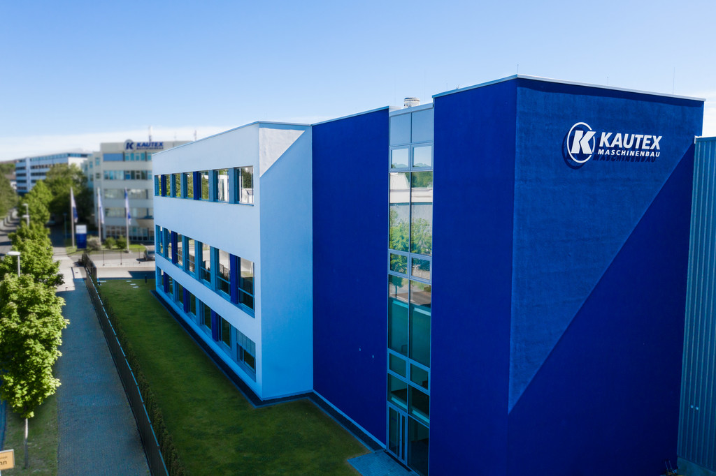

Press image

**About Kautex Maschinenbau**

Kautex Maschinenbau develops smart production solutions for the production of plastic containers. The company has shaped the plastics sector for 85 years with advanced extrusion blow molding machines. It works together with customers and partners to create added value for sustainable, economical production of extrusion blow molding articles of the highest quality.

A worldwide clientèle from a wide range of industrial branches puts its trust in the know-how of a brand which has represented great reliability, durability, and economic benefits for many decades.

As global market leader, the company employs around 550 people. The main production locations are in Germany and China. With more than 150 people employed in the fields of sales and service on all continents, the company is close to its customers in all locations with a unique service package.  
  
**Contact**

Christian Kirchbaumer  
Head of Marketing Communications

Kautex Maschinenbau GmbH  
Kautexstr. 54  
53229 Bonn

T +49 228 489370

christian.kirchbaumer@kautex-group.com